Inheritance

- Single Inheritance
Create two classes named Animal and Dog.
Animal with a single public method Eat() that prints: "eating…"
Dog with a single public method Bark() that prints: "barking…"
Dog should inherit from Animal.
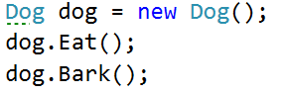
Hints
Use the : operator to build a hierarchy
- Multiple Inheritance
Create three classes named Animal, Dog and Puppy.
Animal with a single public method Eat() that prints: "eating…"
Dog with a single public method Bark() that prints: "barking…"
Puppy with a single public method Weep() that prints: "weeping…"
Dog should inherit from Animal. Puppy should inherit from Dog.
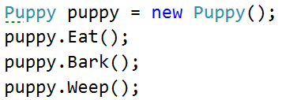
- Hierarchical Inheritance
Create three classes named Animal, Dog and Cat.
Animal with a single public method Eat() that prints: "eating…"
Dog with a single public method Bark() that prints: "barking…"
Cat with a single public method Meow() that prints: "meowing…"
Dog and Cat should inherit from Animal.
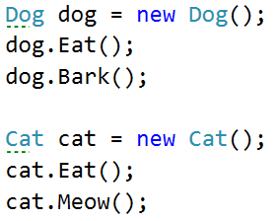

Reusing Classes

- Random List
Create a RandomList class that has all the functionality of ArrayList.
Add additional function that returns and removes a random element from the list.
Public method: RandomString(): string
- Stack of Strings
Create a class StackOfStrings which can store only strings and has the following functionality:
Private field: data: List<string>
Public method: Push(string item): void
Public method: Pop(): string
Public method: Peek(): string
Public method: IsEmpty(): bool

Use composition/delegation in order to have a field in which to store the stack's data

